

FVI - SECS/GEM

User manual

1.0.0.4

2022/08/26

大量科技股份有限公司 TALIANG TECHNOLOGY
桃園市八德區友聯街49號 No. 49, Youlian St., Bade Dist., Taoyuan City 334009, Taiwan
TEL : (03)3686368 / FAX : (03)3685811
目錄
Install
SECS/GEM Driver & Dongle Install 5
User Interface
SECS/GEM Interface - State 6
SECS/GEM Interface - Default SubState 9
SECS/GEM Interface - Manual SV,DV,EC 10
SECS/GEM Interface - Manual Alarm 13
SECS/GEM Interface - Manual Event 14
SECS/GEM Interface - Manual Spooling 15
SECS/GEM Interface - Manual Terminal 16
SECS/GEM Interface - Manual PP 17
Config Interface 18
SYSTEM ID
SYSTEM SV 19
SYSTEM DV 21
SYSTEM EC 22
SYSTEM EVENT 24
EQUIPMENT ID
EQUIPMENT SV 25
EQUIPMENT DV 26
EQUIPMENT EVENT 27
PP BODY 28
SECS/GEM REPORT
EVENT REPORT LINK 32
SECS-II Message LIST
Message List (H -> E) 33
Message List (E -> H) 34
SECS-II Message Example
Stream 1 : Equipment Status
S1F1 : Are You There Request (H -> E) 35
S1F2 : On Line Data (E -> H) 35
S1F3 : Selected Equipment Status Request (H -> E) 36
S1F4 : Selected Equipment Status Data (E -> H) 36
S1F11 : Status Variable Name List Request (H -> E) 37
S1F12 : Status Variable name List Reply (E -> H) 37
S1F13 : Establish Communications Request (H -> E) 38
S1F14 : Establish Communications Request Acknowledge (E -> H) 38
S1F15 : Request Off-Line (H -> E) 39
S1F16 : Off-Line Acknowledge (E -> H) 39
S1F17 : Request On-Line (H -> E) 40
S1F18 : On-Line Acknowledge (E -> H) 40
Stream 2 : Equipment Control and Diagnostics
S2F13 : Equipment Constant Request (H -> E) 41
S2F14 : Equipment Constant Data (E -> H) 41
S2F15 : New Equipment Constant Send (H -> E) 42
S2F16 : New Equipment Constant Acknowledge (E -> H) 42
S2F17 : Date and Time Request (H -> E) 43
S2F18 : Date and Time Data (E -> H) 43
S2F23 : Trace Initialize Send (H -> E) 44
S2F24 : Trace Initialize Acknowledge (E -> H) 44
S2F25 : Loop Back Diagnosis Request (H -> E) 45
S2F26 : Loop Back Diagnosis Reply (E -> H) 45
S2F29 : Equipment Constant Name List Request (H -> E) 46
S2F30 : Equipment Constant Name List Reply (E -> H) 46
S2F31 : Date and Time Send (H -> E) 47
S2F32 : Date and Time Acknowledge (E -> H) 47
S2F33 : Define Report (H -> E) 48
S2F34 : Define-Report Acknowledge (E -> H) 48
S2F35 : Link Event Report (H -> E) 49
S2F36 : Link Event Report Acknowledge (E -> H) 49
S2F37 : Enable/Disable Event Report (H -> E) 50
S2F38 : Enable/Disable Event Report Acknowledge (E -> H) 50
S2F41 : Remote Command Send (H -> E) 51
S2F42 : Remote Command Acknowledge (E -> H) 52
Stream 5 : Alarm Handling
S5F1 : Alarm Report Send (E -> H) 53
S5F2 : Alarm Report Acknowledge (H -> E) 53
S5F3 : Enable/Disable Alarm Send (H -> E) 54
S5F4 : Enable/Disable Alarm Acknowledge (E -> H) 54
S5F5 : List Alarms Request (H -> E) 55
S5F6 : List Alarm Data (E -> H) 55
S5F7 : List Enabled Alarms Request (H -> E) 56
S5F8 : List Enabled Alarm Data (E -> H) 56
Stream 6 : Data Collection
S6F1 : Trace Data Send (E -> H) 57
S6F2 : Trace Data Acknowledge (H -> E) 57
S6F11 : Event Report Send (E -> H) 58
S6F12 : Event Report Acknowledge (H -> E) 58
S6F15 : Event Report Request (H -> E) 59
S6F16 : Event Report Data (E -> H) 59
S6F19 : Individual Report Request (H -> E) 60
S6F20 : Individual Report Data (E -> H) 60
Stream 7 : Process Program Managed
S7F1 : Process Program Load Inquire (H -> E) 61
S7F2 : Process Program Load Grant (E -> H) 61
S7F5 : Process Program Request (H -> E) 62
S7F6 : Process Program Data (E -> H) 62
S7F19 : Current Process Program Dir. Request (H -> E) 63
S7F20 : List Process Program Data (E -> H) 63
S7F25 : Formatted Process Program Request (H -> E) 64
S7F26 : Formatted Process Program Data (E -> H) 64
Stream 9 : System Errors
S9F7 : llegal Data (E -> H) 65
S9F9 : Trace Data Send (E -> H) 65
Stream 10 : Terminal Services
S10F1 : Terminal Request (E -> H) 66
S10F2 : Terminal Request Acknowledge (H -> E) 66
S10F3 : Terminal Display (H -> E) 67
S10F4 : Terminal Display Acknowledge (E -> H) 67
FVI-SECS/GEM Infomation
ReelID Send Log 68
Recipe Change Log 69
Equipment Remote Control Log 70
Equipment Local Control Log 74
End Lot Log 76
Reel Current Status Log 77
Go remote(local) switch Log 78

SECS/GEM Driver & Dongle Install

STEP1 :  Install HASPUserSetup.exe | 
STEP2 :  Insert SECS/GEM Dongle to Computer’s USB port | 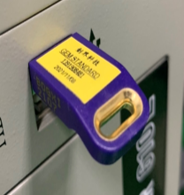

※If the installation fails or the USB cannot be read, the message box will pop up as shown below.

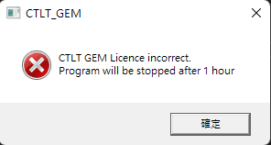

SECS/GEM Interface - State
SECS Connection state
Communicating state
Enable/Disable Comm
Display of current control status
Status toggle field
Messagebox

GEM Initial result show

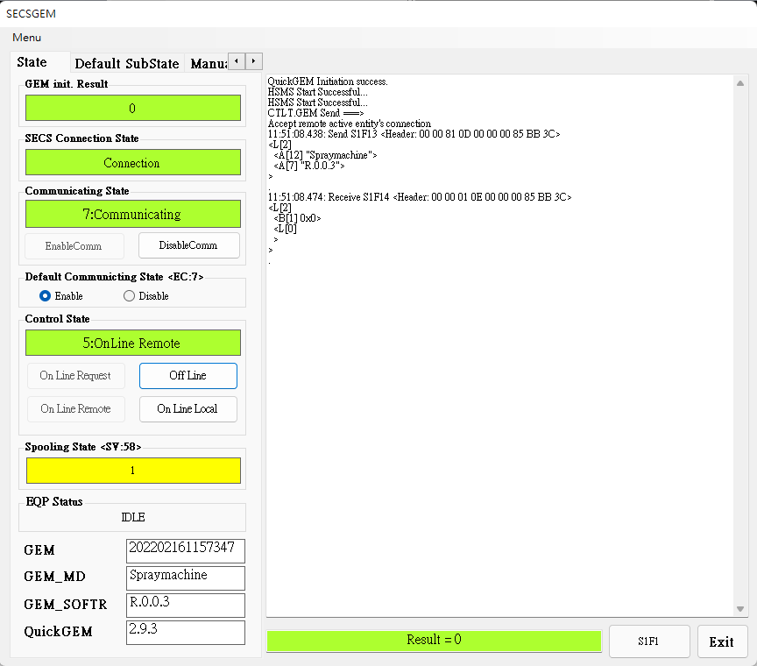
GEM Clock
GEM MODEL Name
GEM Software Version
QuickGEM Software Version

EQ Status show
Spooling State show
Are you there command
Last command result

EnableComm : Start Communication
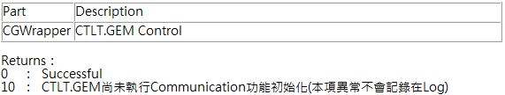
------------------------------------------------------------------------------------
DisableComm : Stop Communication
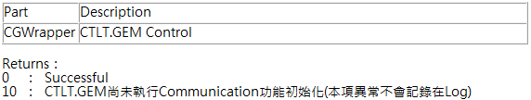
------------------------------------------------------------------------------------
On Line Request : Send the request to connect with the remote On Line
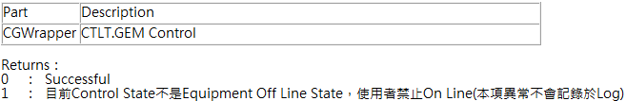
------------------------------------------------------------------------------------
Off Line : Send the request to disconnect with the remote On Line
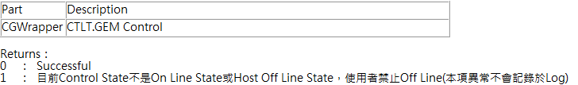

On Line Remote : Switch to remote control status
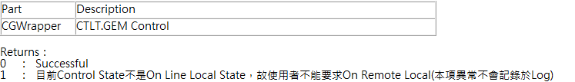
------------------------------------------------------------------------------------
On Line Local : Switch to local control status
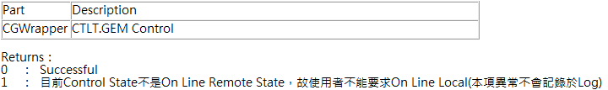

SECS/GEM Interface – Default Substate
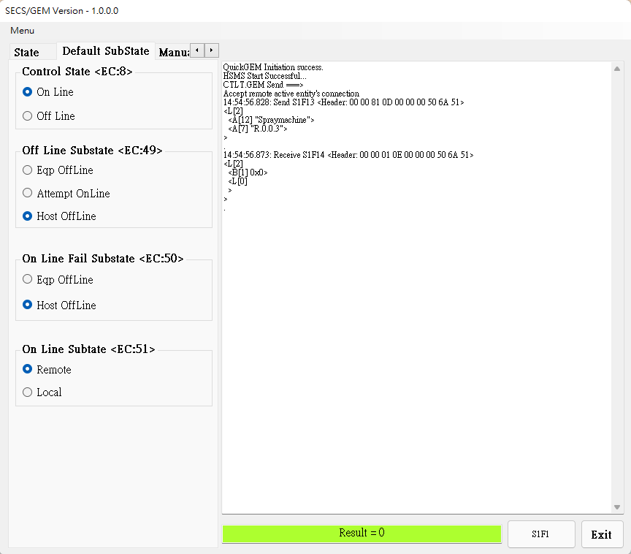
Switch EC:8, EC:49, EC:50, EC:51 ‘s sub state, See [System EC page (p.23) ] for details

SECS/GEM Interface – Manual SV,DV,EC
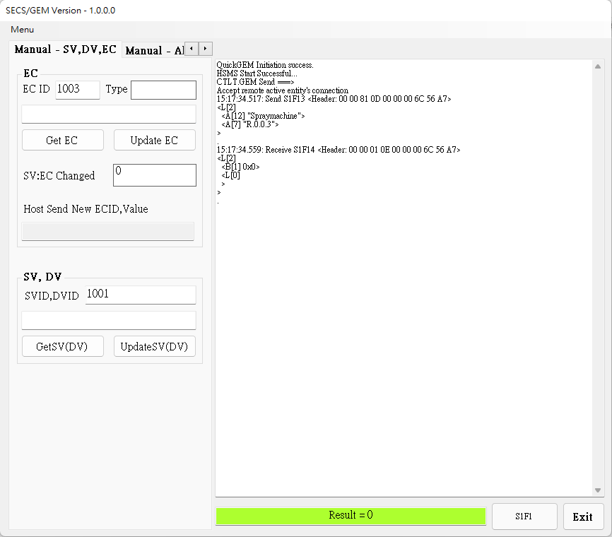
Update EC : Update specified Equipment Constant(EC) value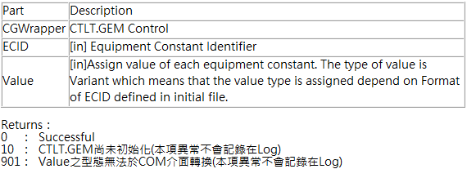

Update SV(DV) : Update specified Status Variable(SV) and Data Value(DV) value
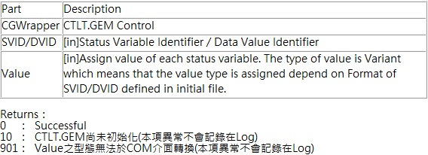
------------------------------------------------------------------------------------
GetEC : Load specified Equipment Constant value
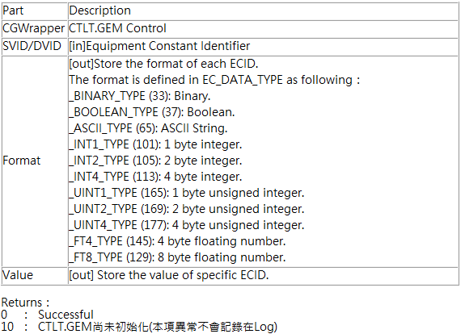

GetSV(DV) : Load specified Status Variable(SV) and Data Value(DV) value
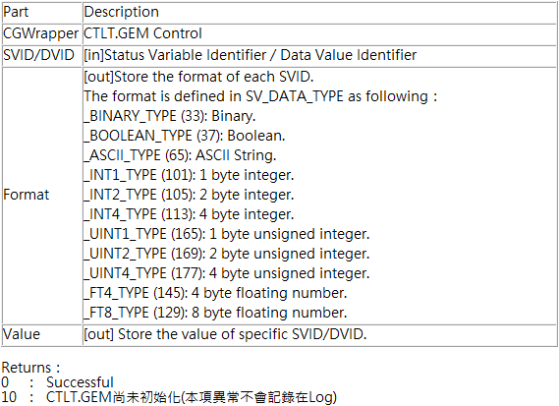

SECS/GEM Interface – Alarm
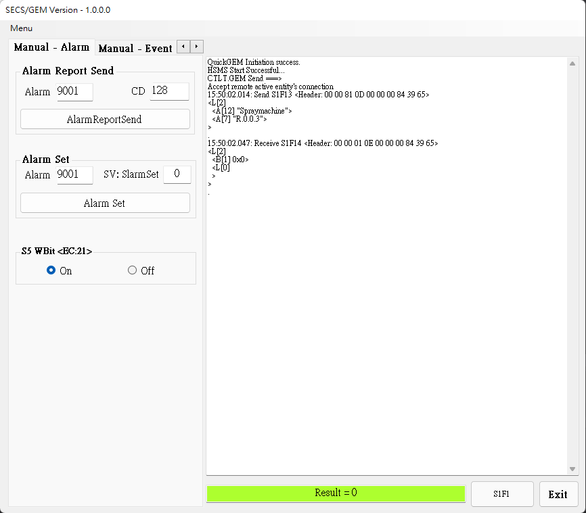
AlarmReportSend : Based on specified Alarm ID send alarm message
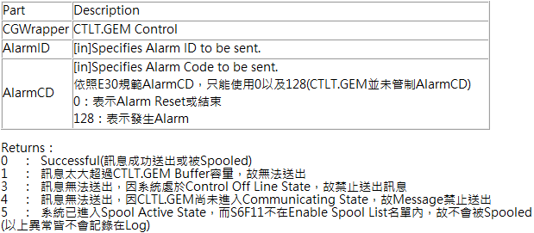
------------------------------------------------------------------------------------
S5 WBit <EC:21> : See [System EC page (p.23) ] for details
SECS/GEM Interface – Event
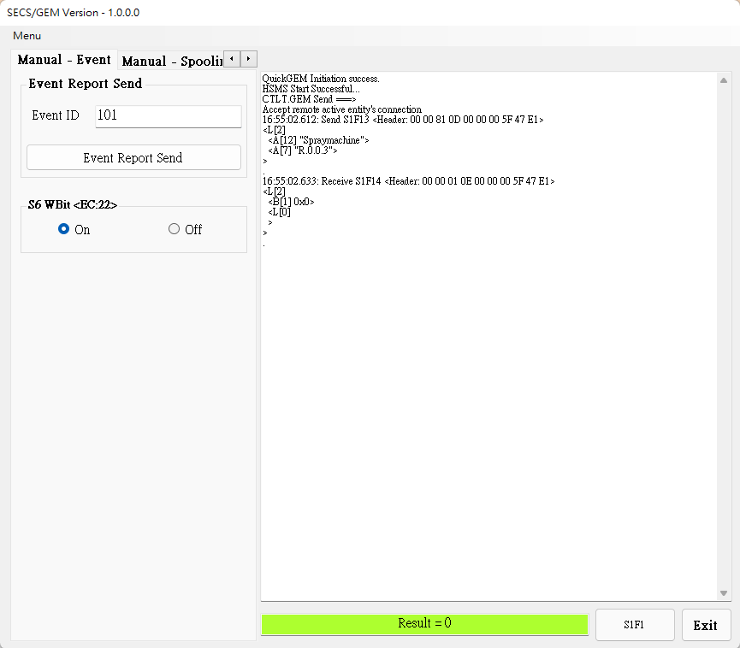
EventReportSend : Based on specified Event ID send event message
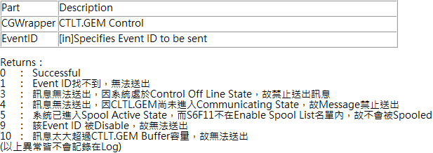
------------------------------------------------------------------------------------
S6 WBit <EC:22> : See [System EC page (p.23) ] for details
SECS/GEM Interface – Spooling
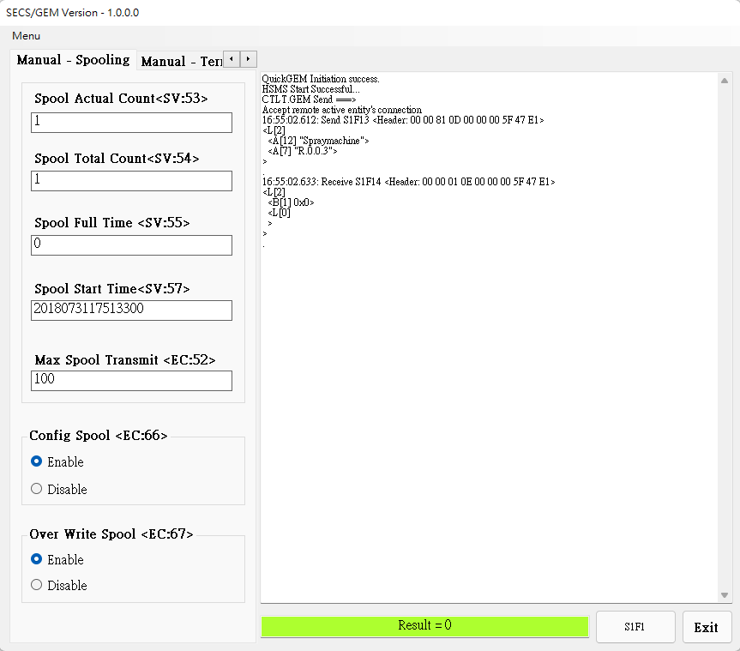
Display SV:53, SV:54, SV:55, SV:57 current value, See [System SV page (p.20) ] for details

Display EC:52current value, See [System EC page (p.23) ] for details

Open/Close EC66, EC67 enable state, See [System EC page (p.23) ] for details

SECS/GEM Interface – Terminal
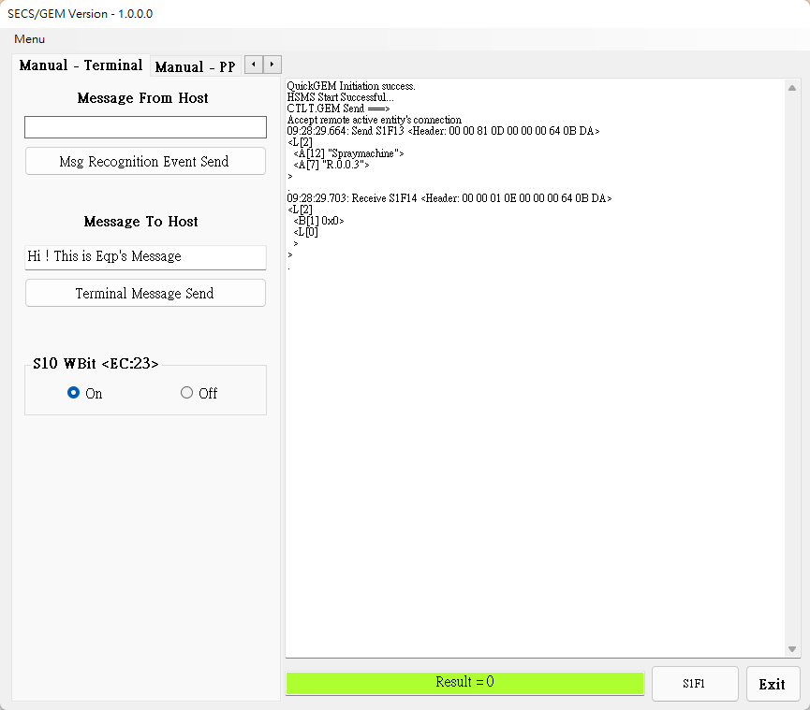
Msg Recognition Event Send: Send terminal message
------------------------------------------------------------------------------------
Terminal Message Send: Send terminal message
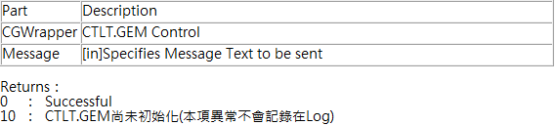
------------------------------------------------------------------------------------
S10 WBit <EC:23> : See [System EC page (p.23) ] for details
SECS/GEM Interface – PP
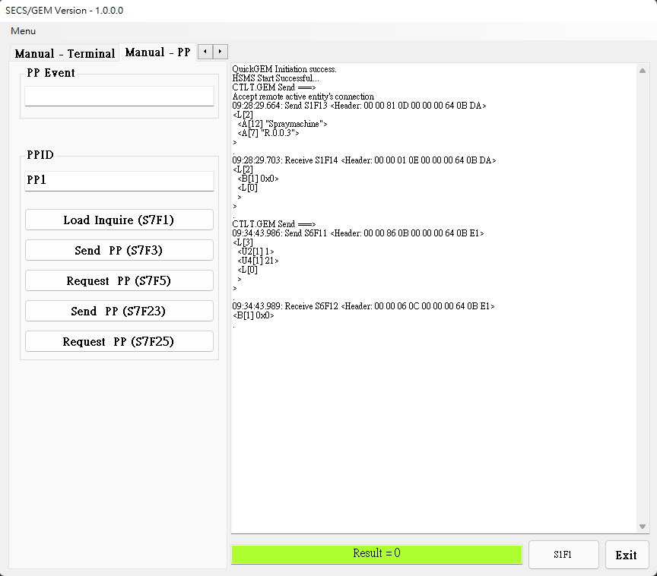
Function specified by excute CmdID
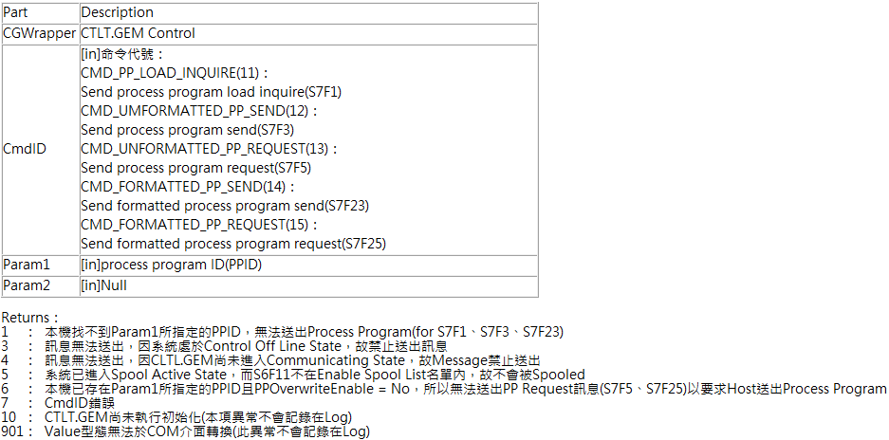
Config Interface
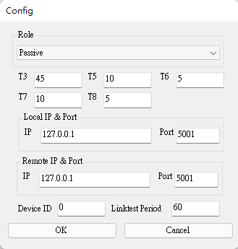
Role : Set the machine as the active side (Host) or the passive side (Equipment)
T3 : Set the time for the sender to wait for the receiver to return a message after sending the data message
T5 : After the TCP/IP connection is set to fail, the active side needs to wait for T5 time before reconnecting
T6 : Set the time for the sender to wait for the receiver to return a message after sending a control message
T7 : Set the time to wait to enter Selected Stats after entering Connected Stats
T8 : Set the maximum time interval allowed between characters in the message when the receiver receives the message
Local IP & Port : Set local IP & Port
Remote IP & Port : Set remote IP & Port
Device ID : Set Device ID
Linktest Period : Set the interval for sending test messages periodically (limited by T6)
System SV

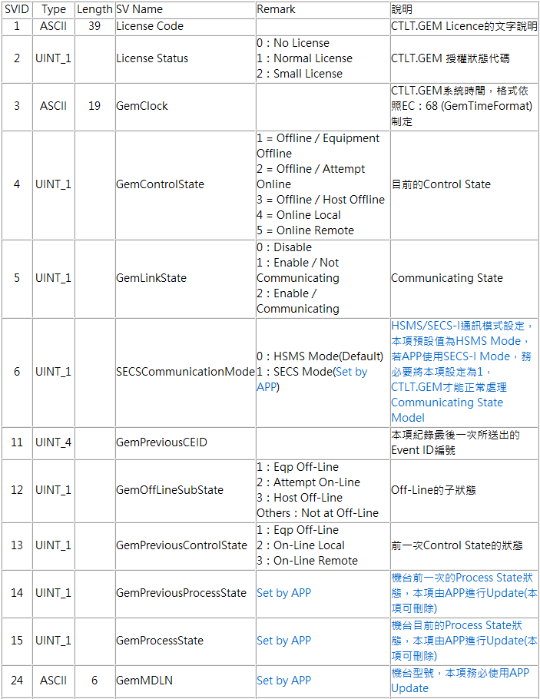

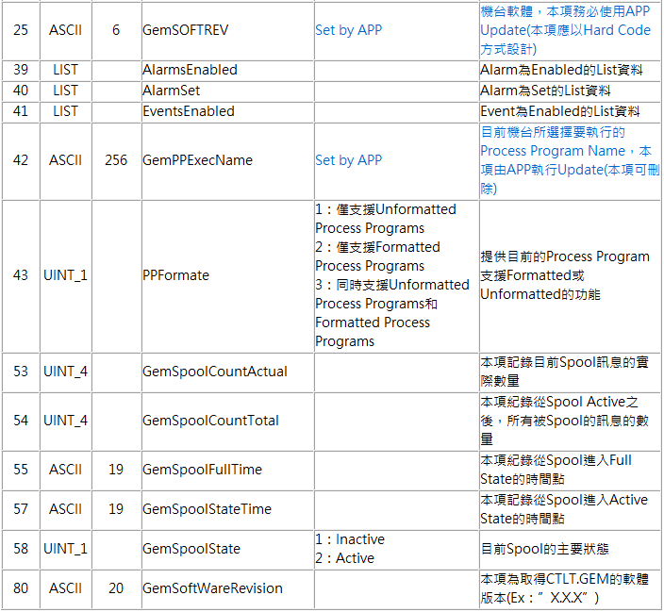

System DV

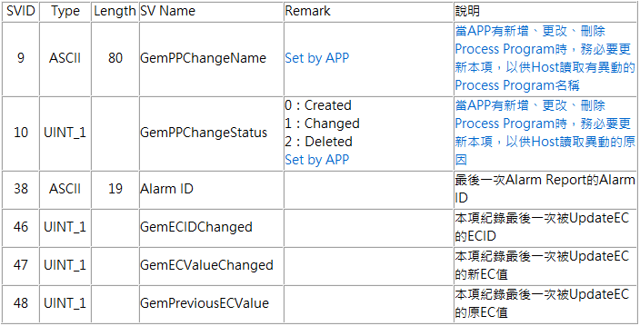

System EC

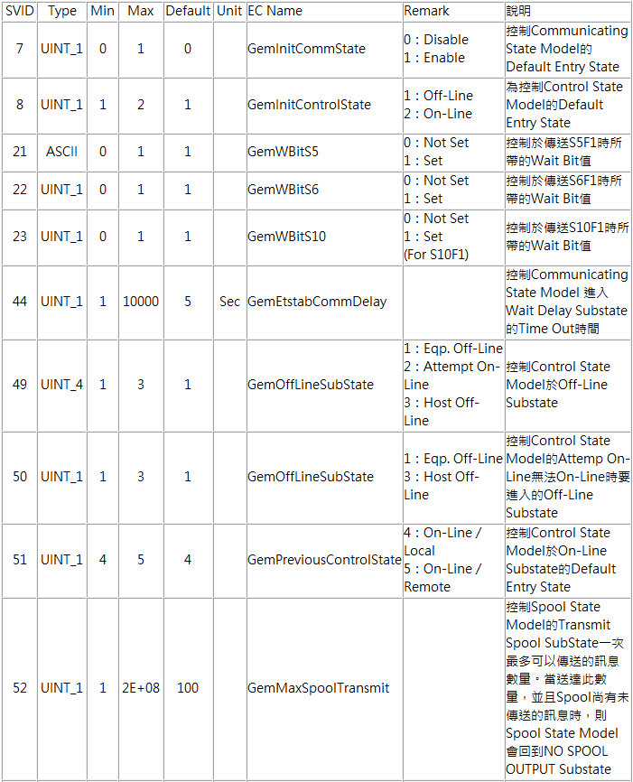

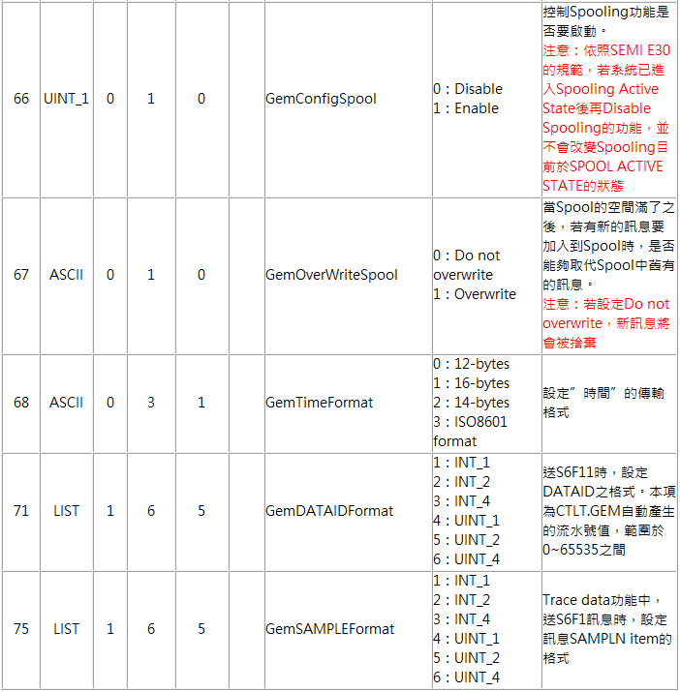

System Event

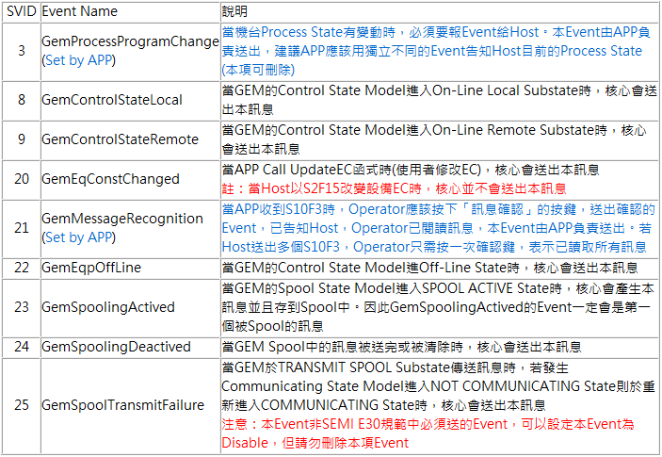

Equpiment SV

ID | TYPE | Lenght | NAME | Definition
1001 | ASCII | 1000 | Equipment_RemoteControlStatus | 遠端控制指令
1002 | ASCII | 1000 | Equipment_RemoteControlResult | 遠端控制指令執行結果
1003 | ASCII | 1000 | Equipment_LocalControlStatus | 設備端控制指令
1004 | ASCII | 1000 | Equipment_LocalControlResult | 設備端控制指令結果
1005 | ASCII | 1000 | Reel_Status | Reel狀態
1006 | ASCII | 1000 | DieCount_CompareResult | Die Count 比對結果

Equpiment DV

ID | TYPE | Length | NAME | Definition
4001 | ASCII | 1000 | ReelID | ReelID
4002 | ASCII | 1000 | APN | APN
4003 | ASCII | 1000 | DateCode | DateCode
4004 | ASCII | 1000 | Lot6 | Lot6
4005 | ASCII | 1000 | CurrentRecipeName | 當前參數名稱
4006 | ASCII | 1000 | Expected_DieCount | 預期Die Count 數量
4007 | ASCII | 1000 | Actual_DieCount | 實際Die Count 數量

Equpiment Event

ID | NAME | Definition
101 | ReelID_Send | 傳送ReelID事件
102 | Recipe_Change | 更換參數檔事件
103 | Equipment_RemoteControl | 遠端控制事件
104 | Equipment_LocalControl | 設備端控制事件
105 | EndLot | 結批事件(Die Count Send)
106 | Reel_CurrentStatus | Reel 安裝/移除事件

PP BODY

[AxisAll]
NAME | Definition
Axis1Pos0 | 左馬達_原點位置
Axis1Pos0Speed | 左馬達_初始速度
Axis1Pos1 | 左馬達_移動距離
Axis1Pos1Speed | 左馬達_速度
Axis2Pos0 | 載帶馬達_原點位置
Axis2Pos0Speed | 載帶馬達_初始速度
Axis2Pos1 | 載帶馬達_移動距離
Axis2Pos1Speed | 載帶馬達_速度
Axis2Pos1SpeedBin | 載帶馬達_速度Bin值
Axis3Pos0 | 右馬達_原點位置
Axis3Pos0Speed | 右馬達_初始速度
Axis3Pos1 | 右馬達_移動距離
Axis3Pos1Speed | 右馬達_速度
Axis4Pos0 | 軸4_原點位置
Axis4Pos0Speed | 軸4_初始速度
Axis4Pos1 | 軸4_移動距離
Axis4Pos1Speed | 軸4_速度
Axis1JogSpeed | 左馬達_吋動速度
Axis2JogSpeed | 載帶馬達_吋動速度
Axis3JogSpeed | 右馬達_吋動速度
Axis4JogSpeed | 軸4_吋動速度
Axis1DataSet | 左馬達_數據集
Axis2DataSet | 載帶馬達_數據集
Axis2DataSet28800 | 載帶馬達_數據集2
Axis3DataSet | 右馬達_數據集
Axis4DataSet | 軸4_數據集

[OtherPar]
NAME | Definition
Stand1NpTime | 載帶整定時間
IndexBSet | A-B距離設定(次數)
NgNpTime | NgNp次數
NozzleErrorSet | 吸嘴設定
YieldErrorSet | 良率錯誤設定
CcdTrgTime | CCD觸發逾時
Ccd6SpaceSet | CCD6設定值
LoadHot1Time | 加溫器加溫時間
LoadHot2TimeDown | 加溫器2降溫時間
LoadHot2TimeUp | 加溫器2加溫時間
LoadReelStopTime | 載入停止時間
LoadCaseStopTime | 載入停止時間
LoadCCD6DelayTime | CCD6延遲時間
LoadHotDelayTime | 加溫訊號延遲
LoadOutTime | 載入時間計時
Axis1AccDec | Axis1馬達加速度
Axis2AccDec | Axis2馬達加速度
Axis3AccDec | Axis3馬達加速度
IndexCSet | 數量到達後移動設定 (次數)
Light1 | A站上側光源
Light2 | A站下側光源
Light3 | B站上側光源
Light4 | B站下側光源
Light5 | C站光源
Light6 | A站底部光源
Light7 | B站底部光源
Light8 | C站底部光源

Event Report Link
Equipment event (p.28) will be transmitted with RTPID and SV, DV, EC values ​​will be transmitted together, as shown below.

EventID | RPTID | SVID, DVID, ECID
ReelID_Send (101) | 101 | ReelID (4001)
Recipe_Change (102) | 102 | CurrentRecipeName (4005)
Equipment_RemoteControl (103) | 103 | Equipment_RemoteControlStatus (1001)  Equipment_RemoteControlResult (1002)
Equipment_LocalControl (104) | 104 | Equipment_LocalControlStatus (1003)  Equipment_LocalControlResult (1004)
EndLot (105) | 105 | Actual_DieCount (4007)
Reel_CurrentStatus (106) | 106 | Reel_Status (1005)

SECS-II Message List (H -> E)

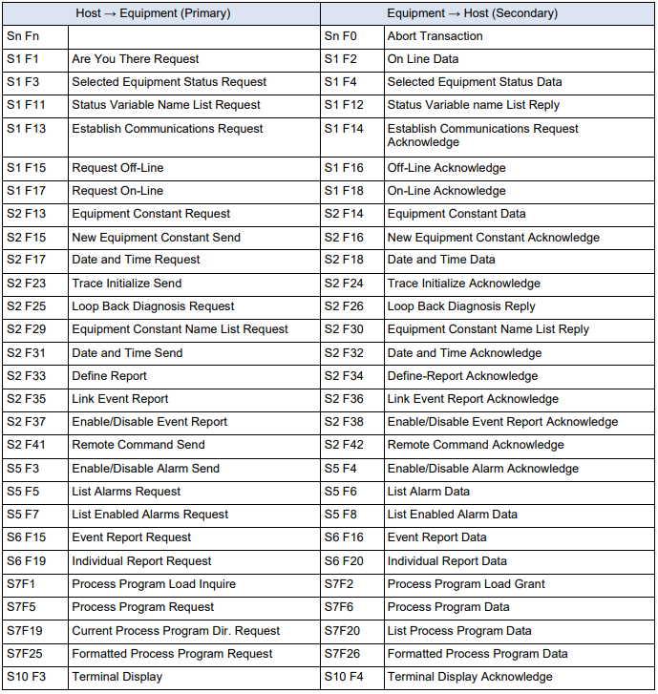

SECS-II Message List (E -> H)

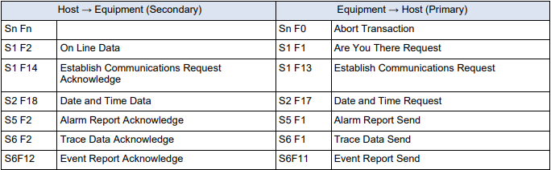

SECS-II Message Example
(Host perspective)

S1F1 : Are You There (H -> E)

Description :
The host may send this message to the EQ at any time. EQ sends this message periodically as a “heartbeat” to determine if the SECS link is alive.

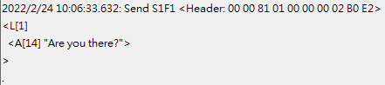

S1F2 : On-Line Data (E -> H)

Description :
EQ reports its Model Number and Software Revision to Host

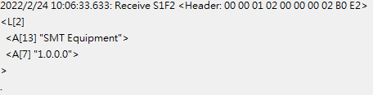

.
S1F3 : Selected Status Request (H -> E)

Description :
A request to EQ to report selected values of its status.

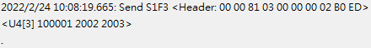

S1F4 : Selected Status Data (E -> H)

Description :
The equipment reports the value of each SVID requested in the order requested.

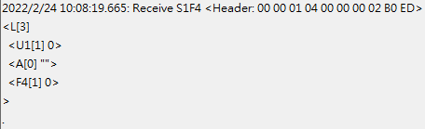

S1F11 : Status Variable NamelistRequest (H -> E)

Description :
A request to the equipment to identify certain status variables.

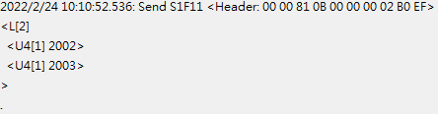

S1F12 : Status Variable Namelist Reply (E -> H)

Description :
EQ reports to the Host the name and units of the requested SVs.

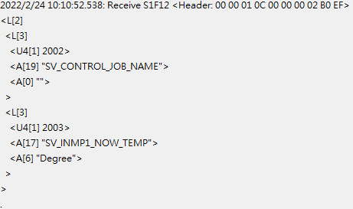

S1F13 : Establish Communication Request (H -> E)

Description:
Either end of the link may send S1F13 as the first message to establish connection of the link. Under EQ’s initialization logic, EQ will always attempt to establish the link. If no Host acceptance reply is received. EQ sends this message periodically.

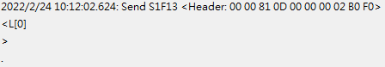

S1F14 : Establish Communication Request Acknowledge (E -> H)

Description:
Accept or deny Establish Communication Request.

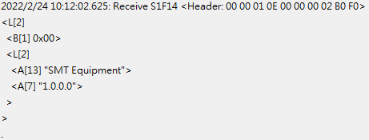

S1F15 : Request Off-Line (H -> E)

Description:
Host requests EQ to go Off-Line

S1F16 : Off-Line Acknowledge (E -> H)

Description:
EQ control state transits to Host Off-Line and sends this message in response to S1F15 primary.

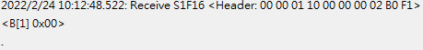

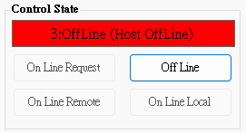

S1F17 : Request On-Line (H -> E)

Description:
Host requests EQ to go On-Line

S1F18 : On-Line Acknowledge (E -> H)

Description:
EQ responds to S1F17 primary in an attempt to go On-Line. Data item ONLACK indicates the success of failure of the attempt.

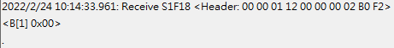

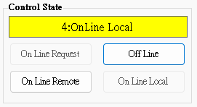

S2F13 : Equipment Constant Request (H -> E)

Description:
Constants and other values that are changed infrequently can be obtained using this message.

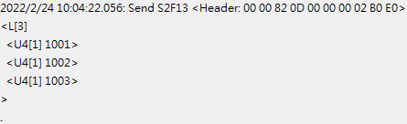

S2F14 : Equipment Constant Data (E -> H)

Description:
EQ returns constant data in the order requested in S2F13.

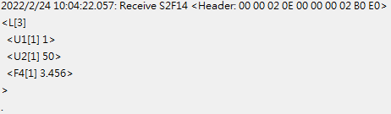

S2F15 : New Equipment Constant Send (H -> E)

Description:
Change one or more equipment constants.

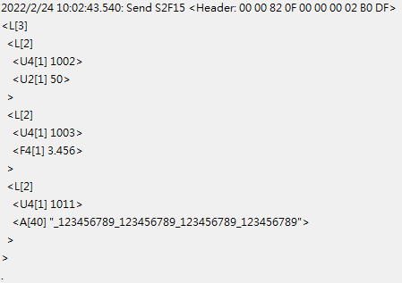

S2F16 : Equipment Constant Send Acknowledge (E -> H)

Description:
Change one or more equipment constants.

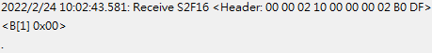

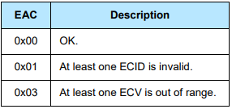

S2F17 : Date and Time Request (H -> E)

Description:
Host sends this message at any time to determine the date and time base EQ is currently using.

S2F18 : Date and Time Data (E -> H)

Description:
Host sends this message at any time to determine the date and time base EQ is currently using.

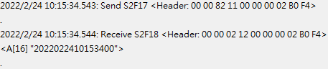

S2F23 : Trace Initialize Send (H -> E)

Description:
Trace initial send to device to enable/disable trace initial data. The trace data is returned on (S6F1) and is related to the original request by the TRID.

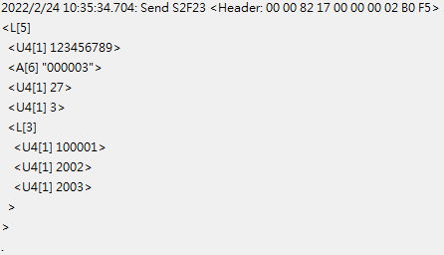

S2F24 : Trace Initialize Acknowledge (E -> H)

Description:
Acknowledge or error for Trace Initialize Send(S2F23)

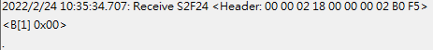

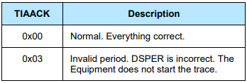

S2F25 : Diagnostic Loopback Request (H -> E)

Description:
Host sends an arbitrary binary string to test operation of the link.

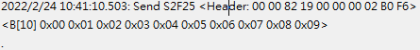

S2F26 Diagnostic Loopback Data (E -> H)

Description:
EQ “echoes” back the binary data from Host’s S2F25.

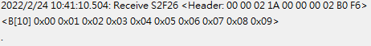

S2F29 Equipment Constant Namelist Request (H -> E)

Description:
This function allows the host to retrieve basic information about what equipment constants are available in the equipment.

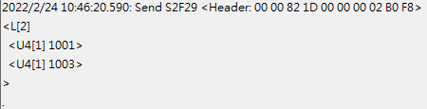

S2F30 : Equipment Constant Namelist Reply (E -> H)

Description:
Data Response for Equipment Constant Namelist Request(S2F29).

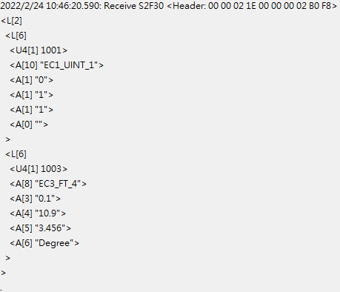

S2F31 : Date and Time Send (H -> E)

Description:
Useful to synchronize the equipment time with the host time base.

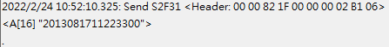

S2F32 Date and Time Acknowledge (E -> H)

Description:
Acknowledge the receipt of time and date.

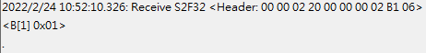

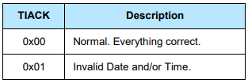

S2F33 Define Report (H -> E)

Description:
The purpose of this message is for the host to define a group of reports for the equipment. The event report will be sent via S6F11 when the event occurred.

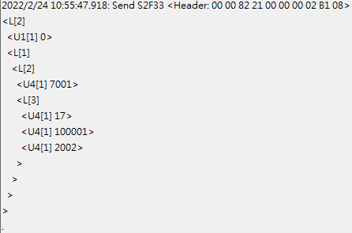

S2F34 Define Report Acknowledge (E -> H)

Description:
Acknowledge or error if an error condition is detected the entire message is rejected(i.e., partial changes are not allowed)

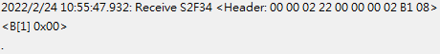

S2F35 : Link Event Report (H -> E)

Description:
The purpose of this message is for the host to link n reports to an event(CEID). These linked event reports will default to ‘disabled’ upon linking. That is, the occurrence of an event would not cause the report to be sent until enabled. See S2F37 for enabling reports.

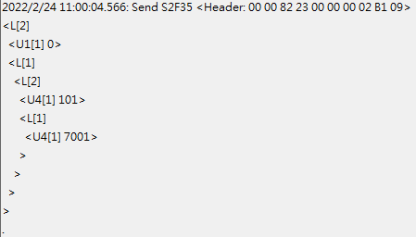

S2F36 Link Event Report Acknowledge (E -> H)

Description:
Acknowledge or error if an error condition is detected the entire message is rejected(i.e., partial changes are not allowed).

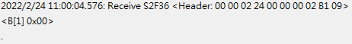

S2F37 : Enable/Disable Event Report (H -> E)

Description:
The purpose of this message is for the host to enable or disable reporting for a group of events(CEIDs).

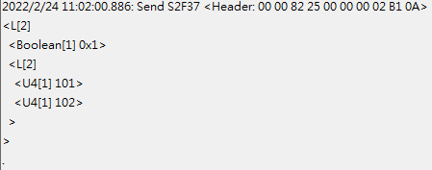

S2F38 : Enable/Disable Event Report Acknowledge (E -> H)

Description:
Acknowledge or error if an error condition is detected the entire message is rejected(i.e., partial changes are not allowed).

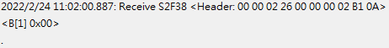

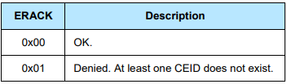

S2F41 : Remote Command Send (H -> E)

Description:
The host requests the equipment perform the specified remote command with the associated parameters.

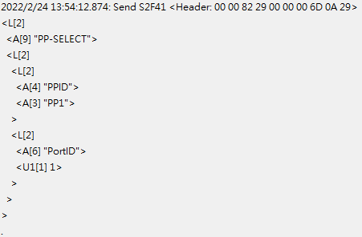

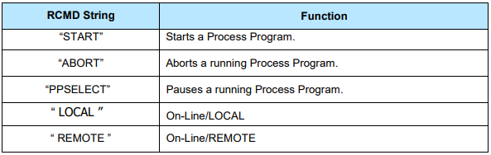

S2F42 : Remote Command Acknowledge (E -> H)

Description:
Acknowledge host’s command or error. If command is not accepted due to one or more invalid parameters, then a list of invalid parameters will be returned containing the parameter name and reason for being invalid.

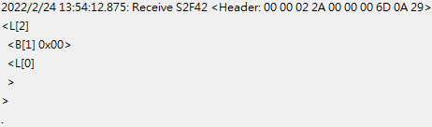

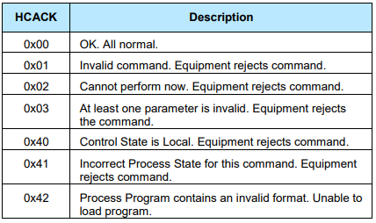

S5F1 : Alarm Report (E -> H)

Description:
This message reports a change in or presence of an alarm condition. One message will be issued when the alam is set and one message will be issued when the alarm is cleared. Irrecoverable errors and attention flags may not have a corresponding clear message.

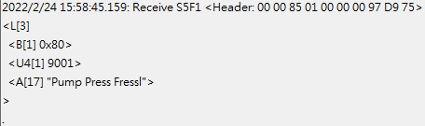

S5F2 : Alarm Acknowledge (H -> E)

Description:
The host acknowledges the alarm report. This equipment ignores the ACKC5.

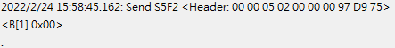

S5F3 Enable/Disable Alarm Send (H -> E)

Description:
This message will change the state of the enable bit in the equipment. The enable bit determines if the alarm will be sent to the host. Alarms which are not controllable in this way are unaffected by this message.

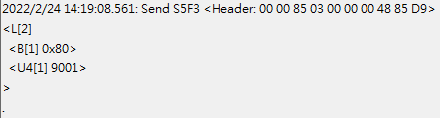

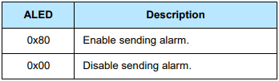

S5F4 Enable/Disable Alarm Acknowledge (E -> H)

Description:
The host acknowledges the alarm report. This equipment ignores the ACKC5.

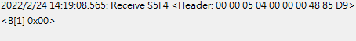

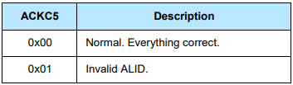

S5F5 : List Alarms Request (H -> E)

Description:
This message requests the equipment to send binary and analog alarm information to the host.

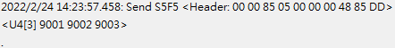

S5F6 : List Alarm Data (E -> H)

Description:
This message contains the alarm data known to the equipment.

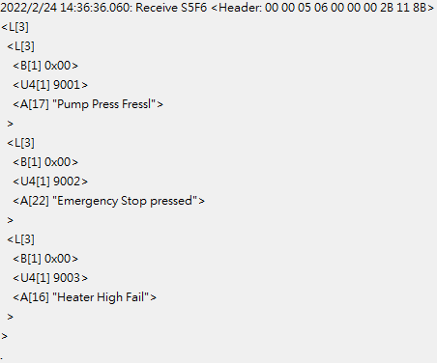

S5F7 : List Enabled Alarms Request (H -> E)

Description:
List all alarms which are enabled .

S5F8 : List Enabled Alarm Data (E -> H)

Description:
This message is similar to S5F6 except that it lists only alarms which are enabled.

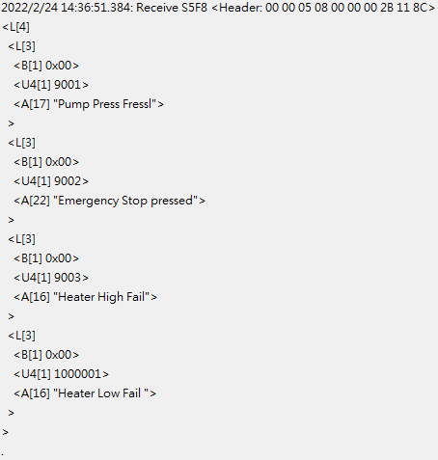

S6F1 : Trace Data Send (E -> H)

Description:
This function sends samples to the host according to the trace setup done by S2F23. Trace is a time-driven form of equipment status.

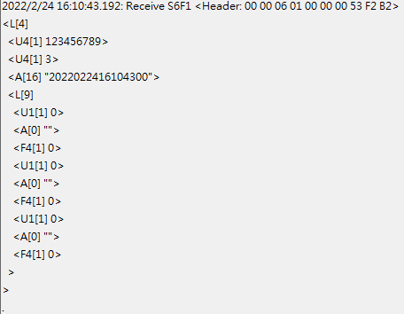

S6F2 : Trace Data Acknowledge (H -> E)

Description:
List all alarms which are enabled .

S6F11 : Event Report Send (E -> H)

Description:
The purpose of this message is for the equipment to send a defined, linked, and enabled group of reports to the host upon the occurrence of an event(CEID).

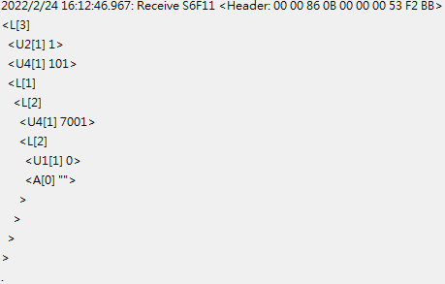

S6F12 : Event Report Acknowledge (H -> E)

Description:
Acknowledge or error for Event Report Send(S6F11).

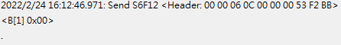

S6F15 : Event Report Request (H -> E)

Description:
The purpose of this message is for the host to demand a given report group form the equipment.

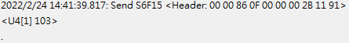

S6F16 : Event Report Data (E -> H)

Description:
EQ sends reports linked to given CEID to host.

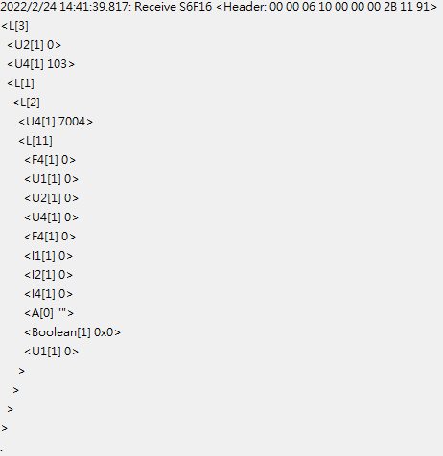

S6F19 : Individual Report Request (H -> E)

Description:
Host requests a Report for the specified RPTID.

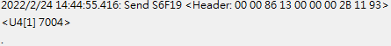

S6F20 : Individual Report Data Event Report Data (E -> H)

Description:
EQ sends variable data defined for the given to the host.

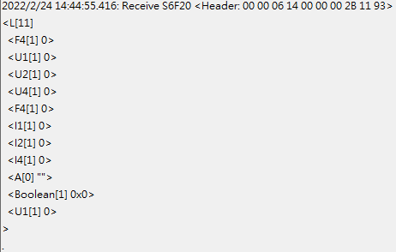

S7F1 : Process Program Load Inquire (H -> E)

Description:
The sender requests permission to send a process program.

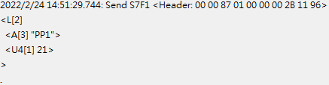

S7F2 : Process Program Load Grant (E -> H)

Description:
The receiver grants permission to send a process program.

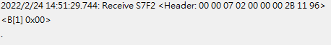

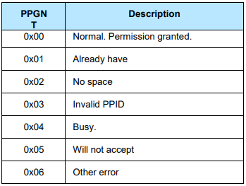

S7F5 : Process Program Request (H -> E)

Description:
Request the other end of the link to send a specified process program from its library.

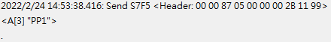

S7F6 : Process Program Data (E -> H)

Description:
Send the requested process program.

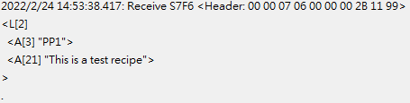

S7F19 : Process Program Dir. Request (H -> E)

Description:
The host requests a directory of the process program currently in the EQ’s library.

S7F20 : Current Process Program Data (E -> H)

Description:
The EQ sends a directory of its process program library. If the library is empty, the list will be zero length.

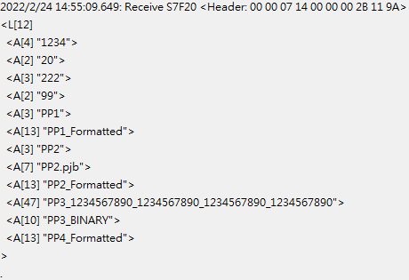

S7F25 : Formatted Process Program Request (H -> E)

Description:
The host requests a process program currently in the EQ’s library.

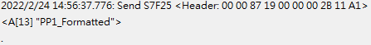

S7F26 : Formatted Process Program Data (E -> H)

Description:
The EQ sends a formatted process program data to the host.

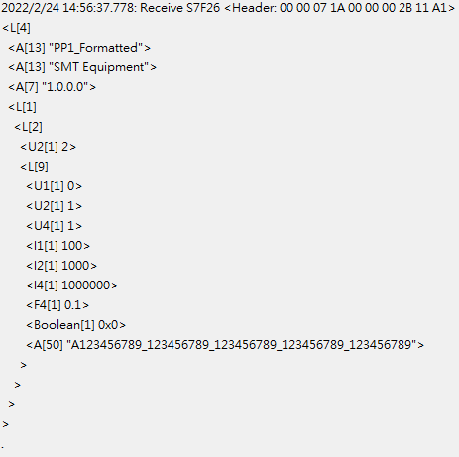

S9F7 : Invalid Data

Description:
This message indicates that the stream and function were recognized, but the associated data format could not be interpreted.

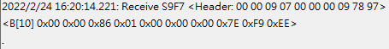

S9F9 : Transaction Timer Timeout

Description:
This message indicates that a transaction (receive) timer has timed out and that the corresponding transaction has been aborted. It is up to the host to respond to this error in an appropriate manner to keep the system operational.

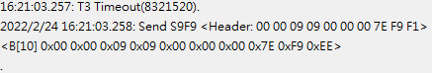

S10F1 : Terminal Request

Description:
A terminal text message to the host.

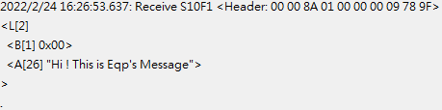

S10F2 : Terminal Request Acknowledge

Description:
Acknowledge or error for terminal request (S10F1).

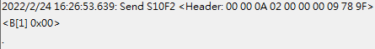

S10F3 : Terminal Display, Single (H -> E)

Description:
Data to be displayed.

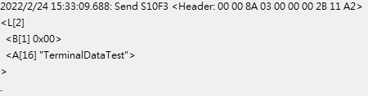

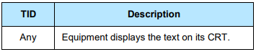
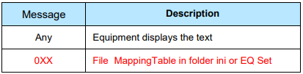

S10F4 : Terminal Request Acknowledge (E -> H)

Description:
Acknowledge or error for terminal request (S10F3).

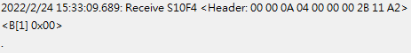

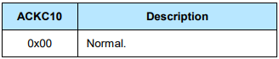

FVI SECS/GEM INFORMATION

ReelID Send LOG

Description:
Equipment will send ReelID (4001) attached to the ReelID_Send (101) event to host, host need to send back APN, DATECODE and LOT6 to equipment.
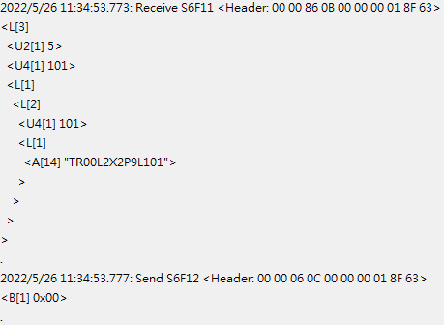
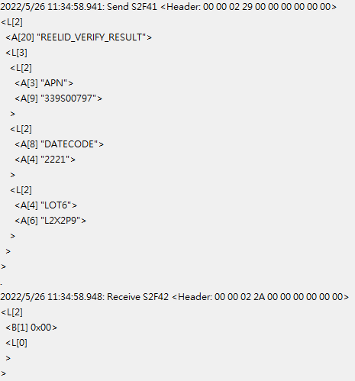
Recipe Change LOG

Description:
Host order Recipe Change command to equipment, equipment will send CurrentRecipeName(4005) attached to the Recipe_Change(102) event to Host when recipe change finished.

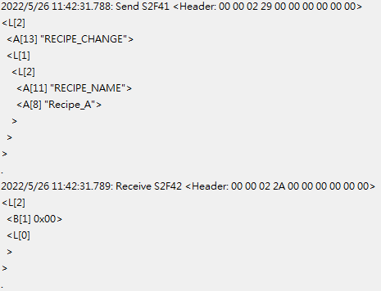
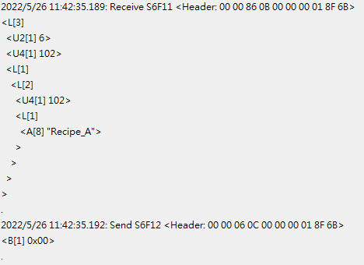

Equipment Remote Control LOG

Description:
Host order REMOTE-START, REMOTE-STOP or REMOTE-RESET command to equipment, equipment will send Equipment_RemoteControlStatus(1001) and Equipment_RemoteControlResult (1002) attached to the Equipment_RemoteControl(103) event to Host.

REMOTE START LOG
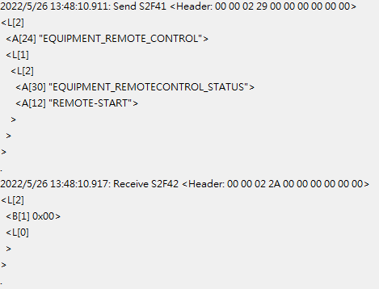

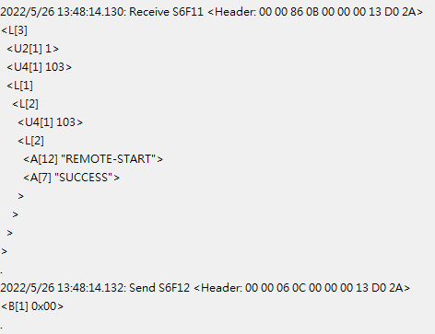
- Equipment_RemoteControlResult will show SUCCESS or FAIL

REMOTE STOP LOG
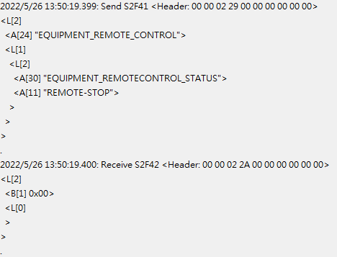

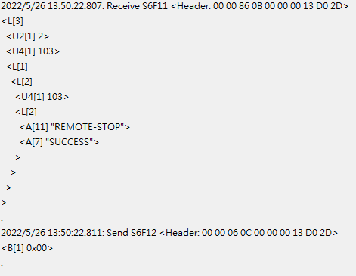
- Equipment_RemoteControlResult will show SUCCESS or FAIL

REMOTE RESET LOG
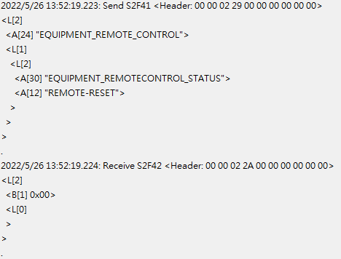

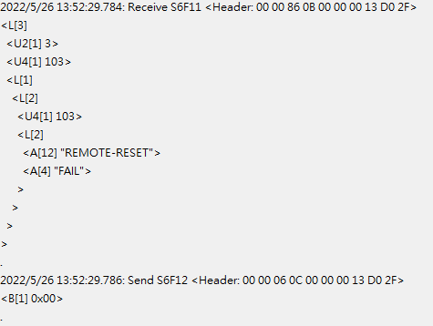
- Equipment_RemoteControlResult will show SUCCESS or FAIL

Equipment Local Control LOG

Description:
Host order LOCAL-START, LOCAL -STOP or LOCAL -RESET command to equipment, equipment will send Equipment_LocalControlStatus(1003) and Equipment_LocalControlResult (1004) attached to the Equipment_LocalControl(104) event to Host.

LOCAL START LOG
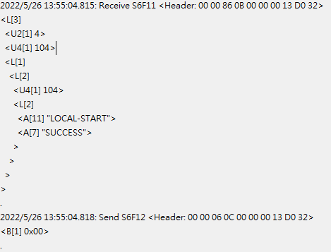
- Equipment_LocalControlResult will show SUCCESS or FAIL

LOCAL STOP LOG
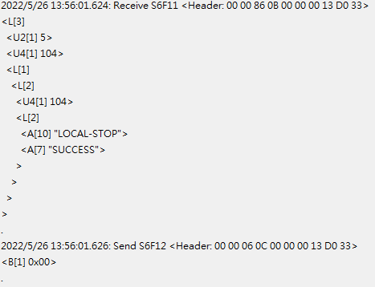
- Equipment_LocalControlResult will show SUCCESS or FAIL

LOCAL RESET LOG
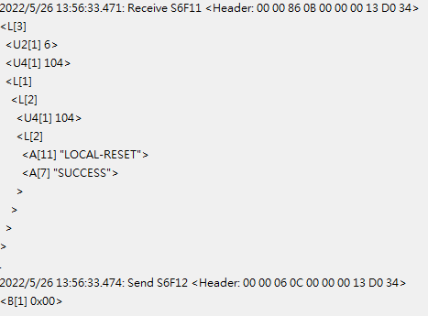
- Equipment_RemoteControlResult will show SUCCESS or FAIL
End Lot LOG
Description:
Equipment will send Reel_ID(4001) and Actual_DieCount(4007) attached to the EndLot(105) event to host, then host need send back expected DieCount and compare result to equipment.

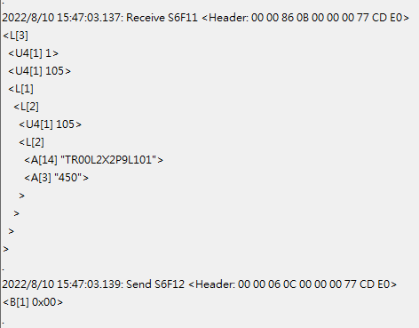
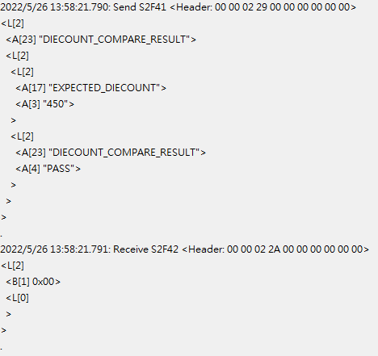
- DIECOUNT COMPARE RESULT please give PASS or NG to it.
Reel Current Status LOG
Description:
Equipment will send Reel_Status(1005) attached to the Reel_currentStatus(106) event to host when Reel has been add or remove.

ADD LOG
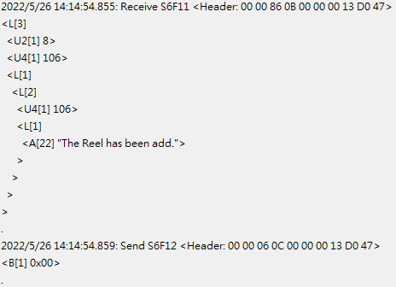

REMOVE LOG
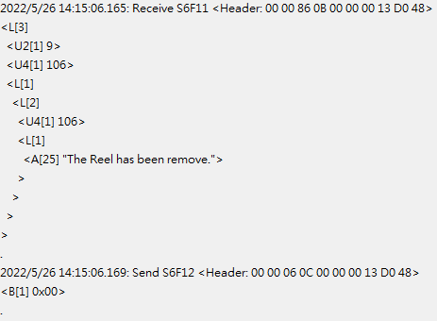
Go remote(local) switch LOG
Description:
Host sned GO-REMOTE(GO-LOCAL) command to equipment, equipment will change control state.

#When equipment in local state, it will only accept “GO-REMOTE” command and block other S2F41 command.

GO REMOTE LOG
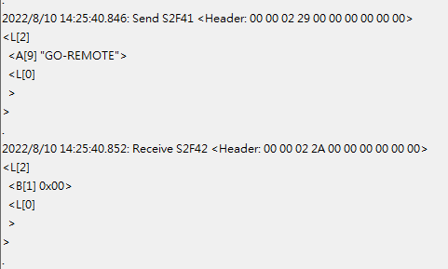
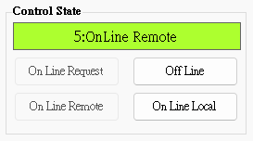

GO LOCAL LOG
